**PROJECT-NAME: FLIPKART**

**Objective:**

Flipkart is **an E-Commerce website** that influences online shopping to every household beyond the world.

**Software Requirements:**

Web technology : HTML, JavaScript, CSS,Bootstrap,React

Web Server : Nodejs

Backend Database : Mango DB

**Home Page:**

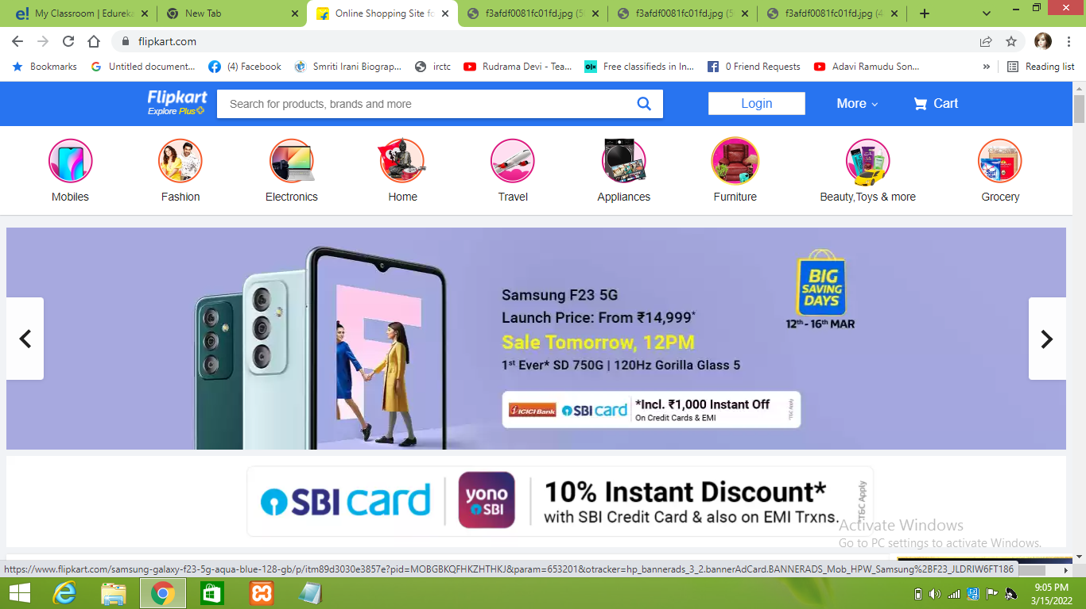

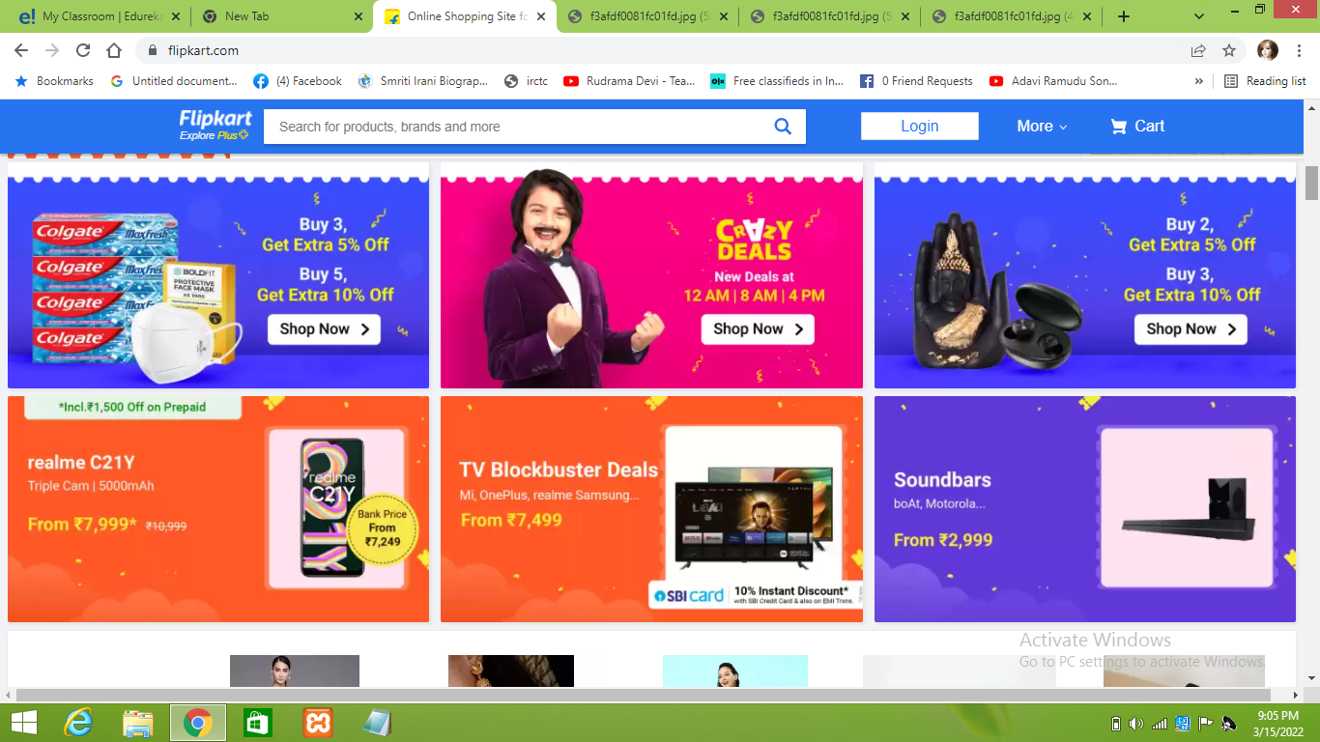

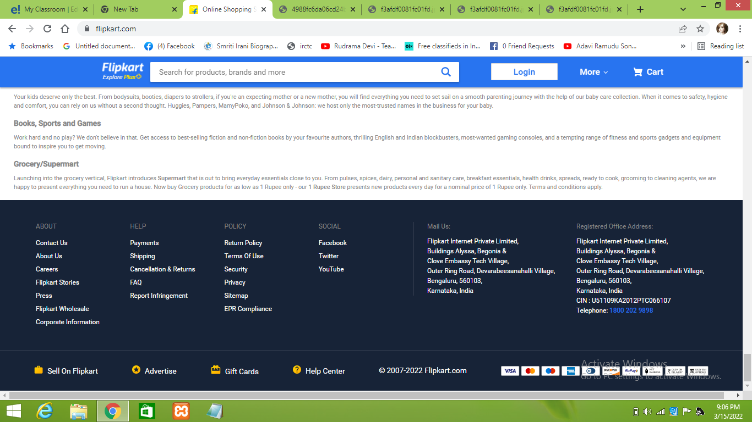

**User Registration Page:**

User want’s to buy any Product first they have to login, by entering valid credientials. Before that user Register by entering valid credientials like Mobile number,email adress,name,adress.After a amobile verification code is send to mobile number or email adress.

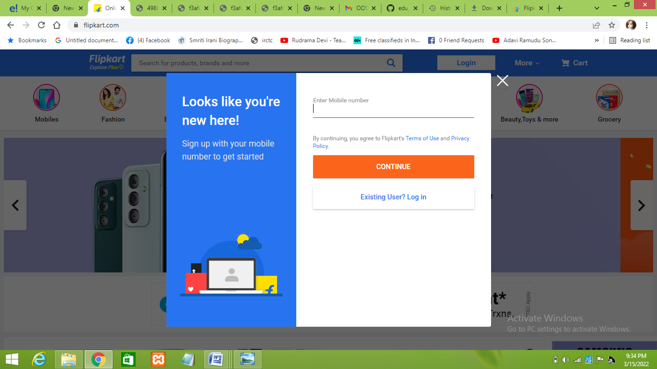

**User Login Page:**

User want’s to buy any Product first they have to login, by entering valid credientials.

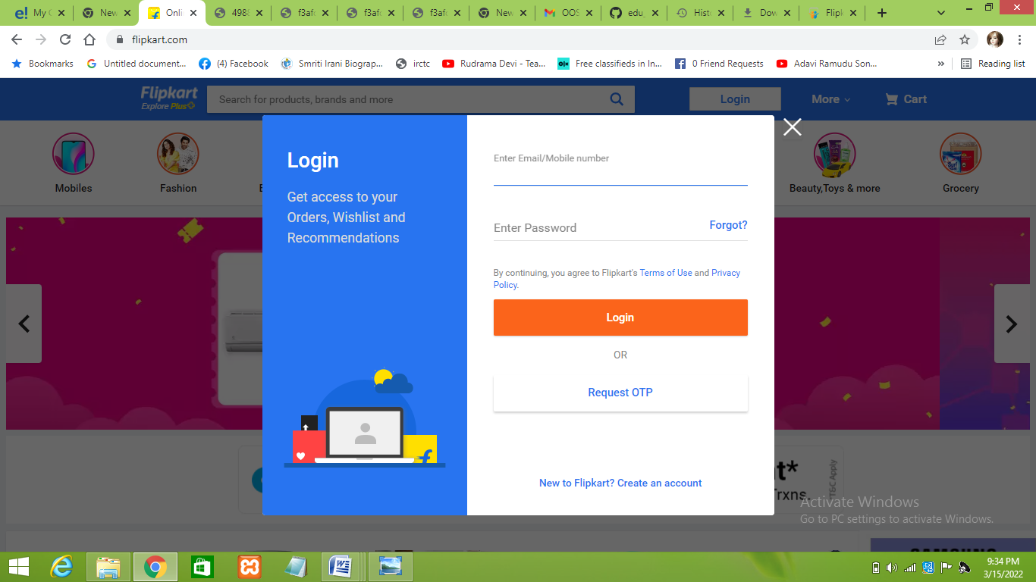

**Registration Form:**

After user login user enter their Personal details.

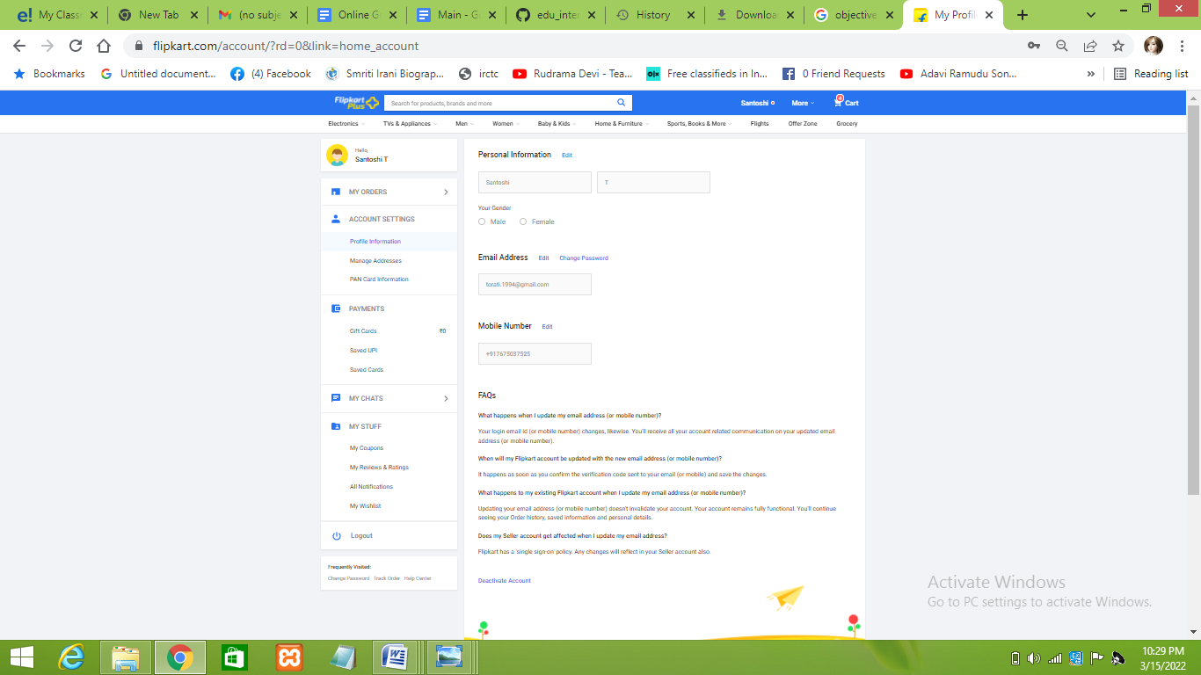

**Product Search Page And Filter Navigation:**

User Can search her/him required product and add to their cart,by applying filters.



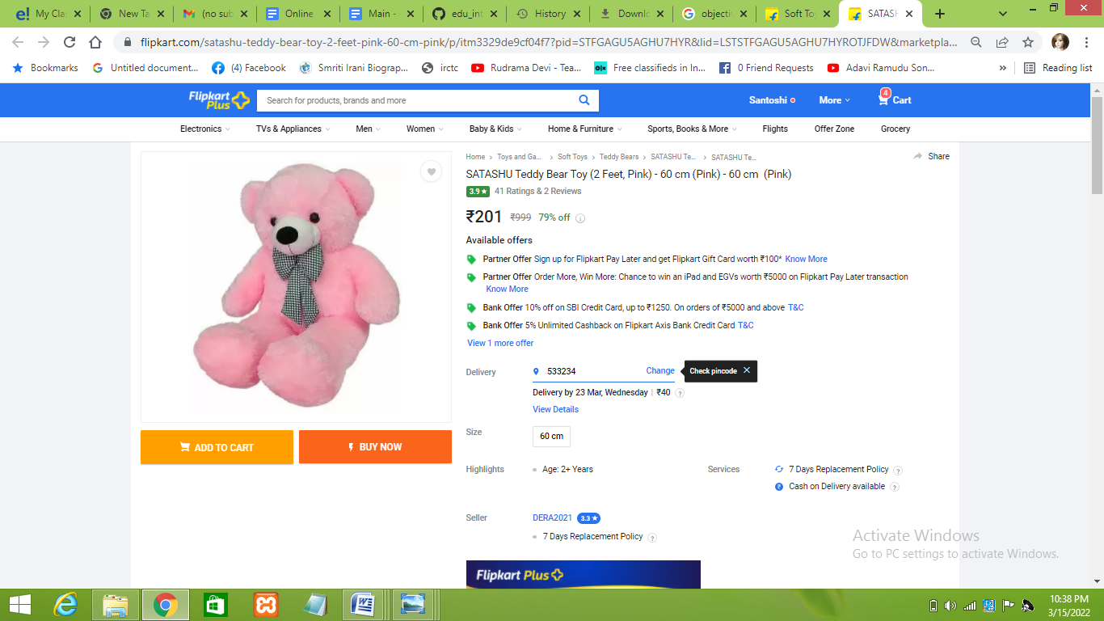

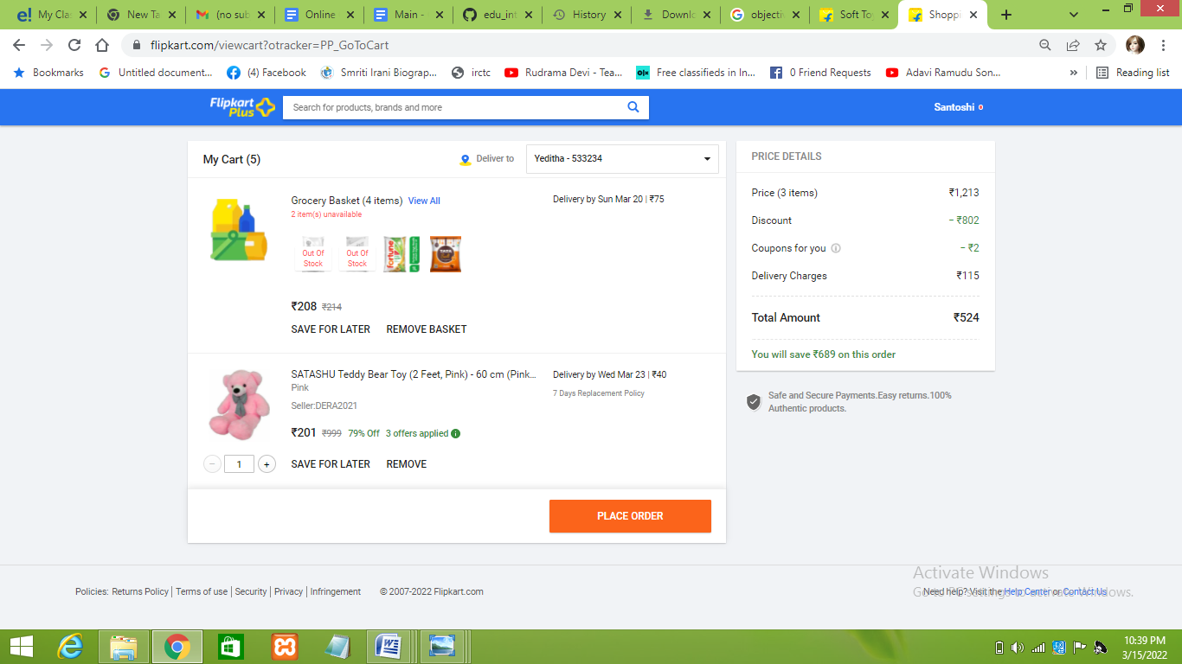

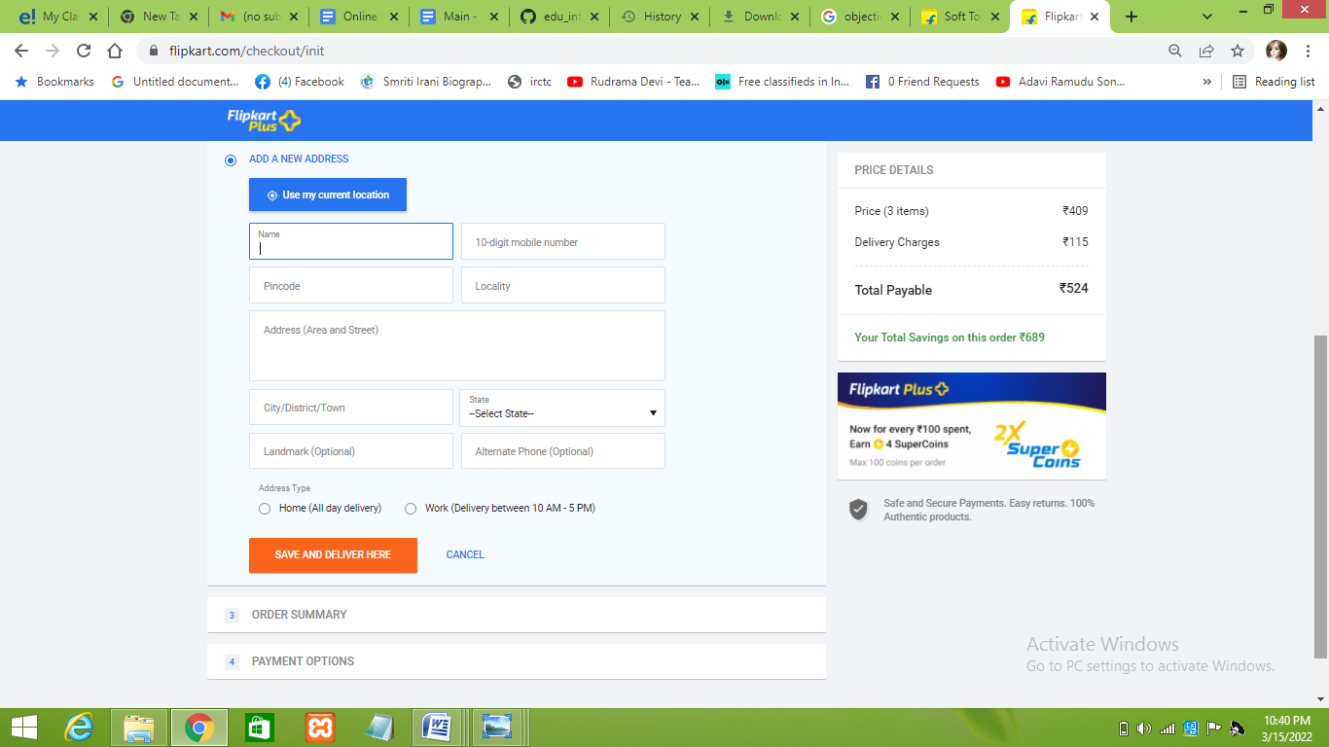

.Now user enter payment details and place orders.

After payment succefull,and order placed success fully message will be displayed.

